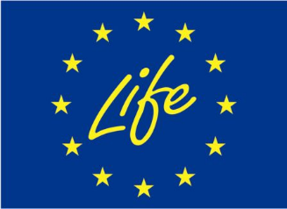

**Green Foundry LIFE project**

**LIFE17 ENV/FI/000173**

**Action D1 Dissemination planning and execution**

**Dissemination plan in 2018-2021**

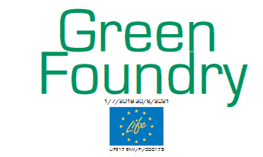

Authors: Meehanite Technology Ltd

Date: 30.12.2018

Content

1 Introduction 3

2 Dissemination activities in Green Foundry LIFE project 4

3 Sub action D.1.1 Networking activities 6

4 Subaction D1.2 List of events arranged or participated by partners 8

5 Subaction D1.2 List of publications produced 9

6 Project website 10

# 1 Introduction

A dissemination plan will be produced where planned dissemination events, seminars, exhibitions and planned publications from all partners will be listed. This plan will be updated annually with all the dissemination and networking activities which have been carried out annually.

In the beginning of this plan the planned events and publications etc. according to the Grant agreement are shortly listed. Pictures and list of participants in project own seminars and Workshops are presented in separate annexes and pictures are also placed on project website [www.greenfoundry-life.com](http://www.greenfoundry-life.com).

During 1.7.2018-28.2.2019 partner have participated in

# 2 Policy Impact

The most important result of the project will be a BAT publication on the usage of inorganic binders in ferrous foundries. The publication will be prepared in TWG BREF in cooperation with the project partners. Prof. Orkas from Technology Industries is a member in the working group and he will present and discuss the results of the project there. Peter Nayström from Swedish Foundry Association is also involved in the project activities and is a member, too. Kari Kirjavainen represents Finnish authorities in the TWG BREF group. Project coordinator and Technology Industry have good contacts with him.

The project partners in six countries have wide and close contacts with the most relevant stakeholders such as policy makers, authorities, foundry associations and local foundries. One of the main forums for dissemination of the project results will be national and international foundry associations. They arrange seminars and annual meetings which gather together most of the decision makers in foundry branch:

* Finland: Suomen Valimotekninen Yhdistys
* Sweden: Swedish Foundry Association- Gjuteriföreningen
* Germany: BDG –German Foundry Association
* Italy: Assofond
* Spain: Spanish Federation of Foundry Associations- FEAF
* France: French Foundry Association- Fondeurs de France
* Poland: Polish Foundrymen’s Association- STOP
* Europe: CAEF Environmental Group
* World: The WFO-The World Foundry Organization

# 2 Planned dissemination activities

**Sub-action D1.1 – Networking with other projects**

At least 30 contacts or face-to-face meetings will be carried out in the scope of the task.

**Sub-action D1.2 – Dissemination planning and Development of the Dissemination Pack**

● 1000-1500 paper copies and electric versions of Layman's Report

● Notice boards in Finland and Spain

● 5 technical publications or articles in relevant magazines

● Website (over 50 000 visitors expected by the end of the project)

● 1000-1500 copies of leaflets in both paper and electric format

● Roll-ups for each partner

● 20-30 events, conferences, meetings and seminars

● Seminar(s) in partner countries (SP FI, IT and FR) at the end of the project for relevant stakeholders (500-1000 persons are informed of project seminars)

● State of Art Workshop for project partners in the beginning of the project in 2018. Partners and relevant stakeholders (10-20) are informed of the Preparatory Workshop.

● Open Workshop for relevant stakeholders for BAT technologies (50-100 persons are informed of the open Workshop) 2020

● Private Workshop for project partners and relevant stakeholders at the end of the project

● Project seminar arranged in 2021 by VALTY as a conclusion of project outcomes and results to wider audience (250-300 persons are informed of the project seminar)

Project relevant stakeholders in Europe to contact and invite to project events e.g.:

● Foundries in Finland, France, Italy and Sweden through direct cooperation and dissemination

● Foundries in Europe through general networking and dissemination

● Foundry associations and institutes in Europe (Assofond in Italy, FEAF in Spain, FICME in UK, Association of Hungarian Foundries in Hungary, Swedish Foundry Association and Swerea Swecast in Sweden, Foundry Association in Norge, CAEF in Germany)

● Binder system suppliers (e.g. Hüttenens-Albertus GmbH, ASK Chemicals GmbH, Beijer Industri AB, Sweden, VESUVIUS GmbH Standort Borken, etc.)

● Authorities in Finland, Italy, France and Sweden

● Governmental environmental protection representatives

● Environmental protection action groups and eco-institutes

● Healthcare sector

● Politicians with economic and environmental emphasis (“policy makers in Europe”)

● Composters and waste treatment companies for cleaning the inorganic and organic surplus foundry sands by composting method.

Most relevant events in Europe where participate during the project:

● Waste, Water and Environment in Finland (25 000 visitors)

● Subcontracting Trade Fair in Finland (20 000 visitors)

● Foundry Technology and Melting Furnace (GIFA) in Germany (50 000 visitors)

● Foundry Days in Hungary (200 professionals)

● ELMIA Fair in Sweden (15 000 visitors)

● ITM Fair and METALFORUM Exhibition in Poland (18 000 visitors)

● Tallinn International Fair for Production Engineering, Industrial Equipment, Tooling, Subcontracting and Technical Service in Estonia (4 000 visitors)

● Subcontracting and Maintenance for Tech Industry in Latvia (19 000 visitors)

# 3 Sub action D.1.1 Networking activities

As part of the dissemination planning and execution, the project information and results will be networked with other EU funded projects, including LIFE. **At least 30 contacts or face-to-face meetings in the scope of the project tasks.**

The networking will be done between the representatives of other projects and between the stakeholders of target group projects. The aim of these activities is to demonstrate the impact and results related to implication of inorganic moulding system, to minimize emissions, improve the indoor air quality of foundries and foster the surplus foundry sand recycling.

|  |  |  |  |  |  |
| --- | --- | --- | --- | --- | --- |
| **Project name** | **Years** | **Website** | **Form of information exchange** | **Meetings/Contacts** | **Contact information** |
| Eureka Project E!4542 Cleanbinders Europe | 2009-2012 | http://www.eurekanetwork.org/project/id/4542 | Potential inorganic binder system supplier for test casts in Karhula Foundry in Finland and FOM Tacconi foundry in Italy. | Emails, meeting has been planned in Finland in 2-3/2019. | Peak International Products B.v. (Theo Kooyers)  tjk@peak.nl |
| Gietech-GO | 2016-2019 | https://www.gietech-go.eu/ | This project is continuation for Cleanbinders Europe project. Potential inorganic binders for test casts in Green Foundry project will be discussed and meeting arranged. | Emails, meeting has been planned in Finland in 2-3/2019. | Peak International Products B.v. (Theo Kooyers)  tjk@peak.nl |
| Foundrytile (LIFE14 ENV/ES/000252) | 2015-2018 | https://www.foundrytile.eu/ | Exchanging experiences related to the valorization of iron foundry sands and dust in the ceramic tile production process. | Emails. ARABA partner (Spain) networking with the coordinator, Fundació CTM Centre Tecnològic, Spain.  Email on 17.12.2018 | [foundrytile@ctm.com.es](mailto:foundrytile@ctm.com.es) |
| LifeCeram LIFE12 ENV/ES/000230 | 2013-2016 | https://www.lifeceram.eu/en/ | Exchanging experiences in developing a new ceramic tile, consisting mainly of waste, for outdoor applications. | Contacting for more information.  Email on 17.12.2018 | Instituto de Tecnología Cerámica (ITC), itc@itc.uji.es www: http://www.itc.uji.es/ |
| Foundrysand (LIFE13 ENV/FI/000285) | 2014-2017 | http://life-foundrysand.com/ | Green Foundry LIFE project is partly continuation for Foundrysand project. Close cooperation with the partners and pilot foundries. Results from the Foundrysand project will be utilised in the demonstration actions related to reuse and cleaning the inorganic surplus foundry sand in Green Foundry LIFE project. | Cooperation with pilot foundries and partners | Meehanite Technology Oy, Finland |
| LIFE EcoSandfill | 2016-2019 | www.life-ecosandfill.eu | The project aims at demonstrating the technical, economic and environmental feasibility of using reclaimed Spent Foundry Sand (SFS), properly pre-processed through innovative mechanical treatments, as fine aggregate in three construction applications. Exchanging information of reclamation method and results will be made between these projects. | Cooperation planned. Emails on 19.12.2018 | Most relevant project. Contacted on 19.12.2018 for a conference call |
|  |  |  |  |  |  |
|  |  |  |  |  |  |
|  |  |  |  |  |  |

# 4 Subaction D1.2 List of relevant events participated in 1.7.2018-31.3.2019

|  |  |  |  |  |  |  |  |  |
| --- | --- | --- | --- | --- | --- | --- | --- | --- |
| **Date** | **Name of the event/seminar/exhibition** | **Place, country** | **Form of participation e.g. presentation/dissemination materials/stand** | **Number of participants in the event** | **Target audience** | **National/**  **International** | **Partner(s)** | **Participated/Expected** |
| 6-7.11.2018 | Kick-off meeting for LIFE projects 2017 | Brussels, BE | Green Foundry project presentation | 50 | LIFE project representatives, NEEMO, EASME | International | Meehanite | P |
| 15.11.2018 | Green Foundry kick-off meeting | Tampere, FI | Green Foundry project objectives, activities, timetables, financial issues | 22 | Partners, inorganic binder system suppliers | International | All partners + 3 system suppliers + research organisation | P |
| 28-29.3.2019 | “Valun käytön” –seminar | Tampere, FI | Project presentation by Meehanite/Valty | 100 | Foundry representatives, system suppliers | national | AX, Valty |  |
| 14.12.2018 | Polish Foundrymen’s Day 2018 | Kraków, PL | Presentation of the project (conference programme, printed materials)  https://odo.foundry-conference.com/en/ | 220 | Foundry managers, engineers, research people, Polish Foundrymen´s Association | International | AGH | P |
| 16.1.2019 | RekryLAB-days was arranged at Tampere in Tampere University and Tampere University of Applied Sciences | Tampere, FI | Project presentation and dissemination materials  https://rekrylab.com/mika-on-rekrylab/ | About 200-300 | Students, professors, researches in the field of environmental and energy-, bio- or material technique and companies from that fields | national | AX | P |
| 7-8.2.2019 | SVY opintopäivät | Tampere | Project dissemination material/presentation | 40 | Foundry engineers | national | Valty | P |
| March 2019 | European Coating Show | Nürnberg | Dissemination material at IFAM fair booth |  | Raw material suppliers | international | IFAM | P |

## 4.1 Subaction D1.2 Future events and articles in the project 2019-2021

Partner: VALTY



Partner: UNIPG

## 

Partner: IFAM



Partner: Meehanite and AX



Partner: ARABA

Partner: CTIF

Partner:

# 5 Subaction D1.2 List of publications produced 1.7.2018-31.3.2019

|  |  |  |  |  |  |  |  |  |
| --- | --- | --- | --- | --- | --- | --- | --- | --- |
| **Year** | **Name of magazine** | **Name of article** | **Website** | **Circulation of the magazine** | **Language** | **Paper/electric version** | **Partner** | **Produced/expected** |
| 2019 | AX –lehti | Green Foundry LIFE project | not available | 1300 | Finnish | P | Meehanite | P |
| 2019 | Valimo-viesti | Green Foundry LIFE project presentation | www.svy.info/valimoviesti.html | 1000 | Finnish | P | Meehanite | E |
| 2019 | Metals | ?? | <https://www.mdpi.com/journal/metals/>  special_issues/metals_casting | ?? | English | P (primarly) | IFAM | E |
| 2019 | Foundry Journal of the  Polish Foundrymen´s  Association 11-12-2018 | Inorganic binder investigations-  Green Foundry LIFE project |  | 250-300 | Polish &  English | P | AGH | P |

# 6 Project website

Project website was opened in November 2019 [www.greenfoundry-life.com](http://www.greenfoundry-life.com).

Coordinator will update news, events, project activities on the website. There is a private and public site. Username is visitors and password is Greenfoundry.

In the private site the project agendas, memos and project deliverables will be placed. In public site the general descriptions, results and public deliverable reports and Layman´s report, After LIFE Communication and progress reports will placed.

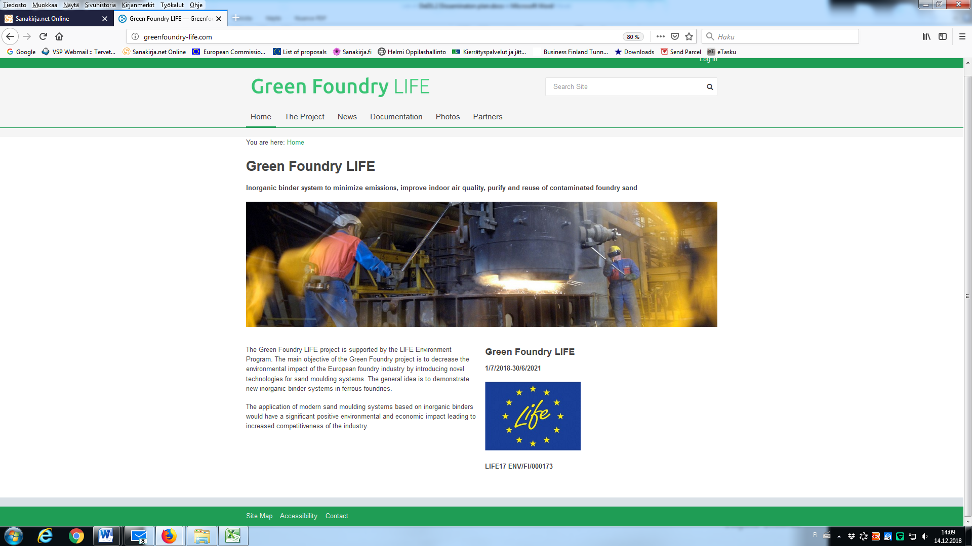

# 7 Photos of events

1. Kick-off meeting in Tampere on 15.11.2018 in Tampere, Finland.

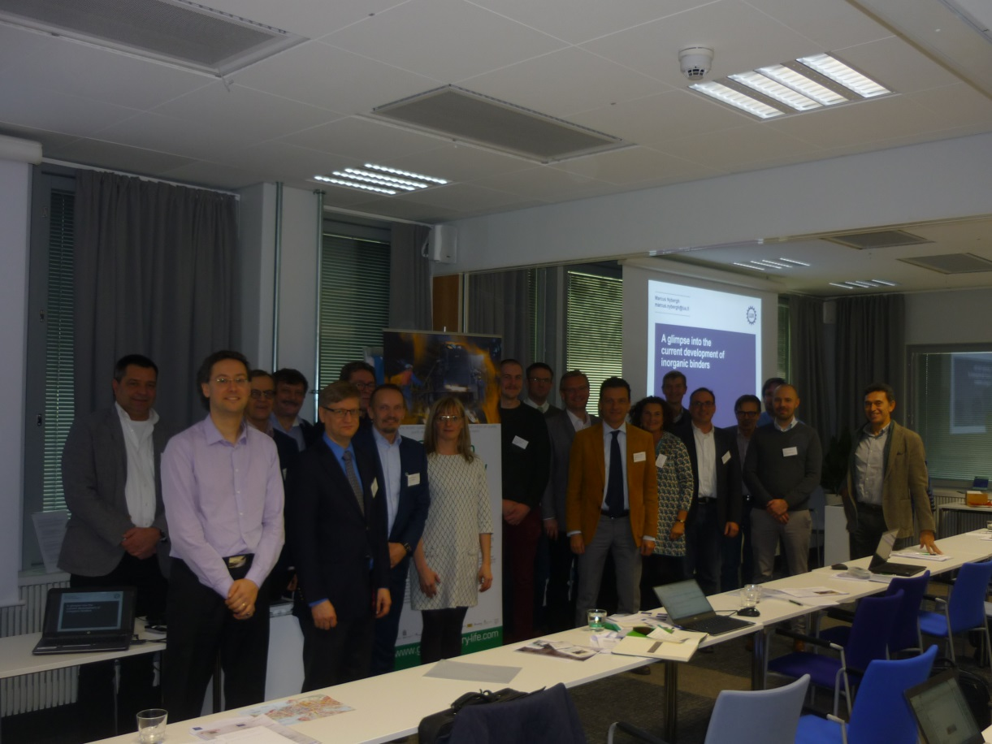

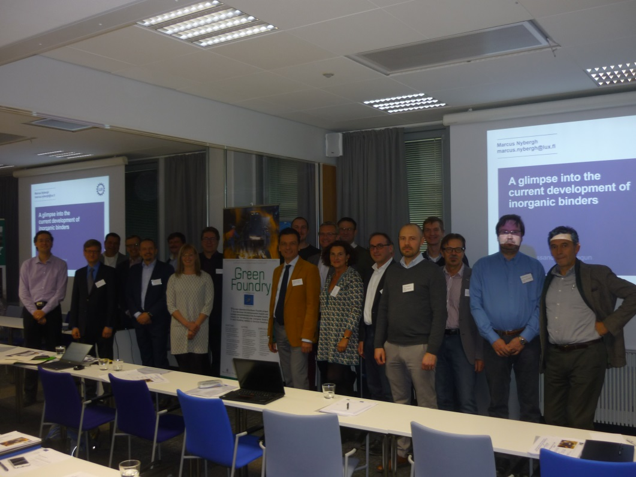

1. RekryLAB-days was arranged at Tampere in Tampere University and Tampere University of Applied Sciences on 16th of January 2019.

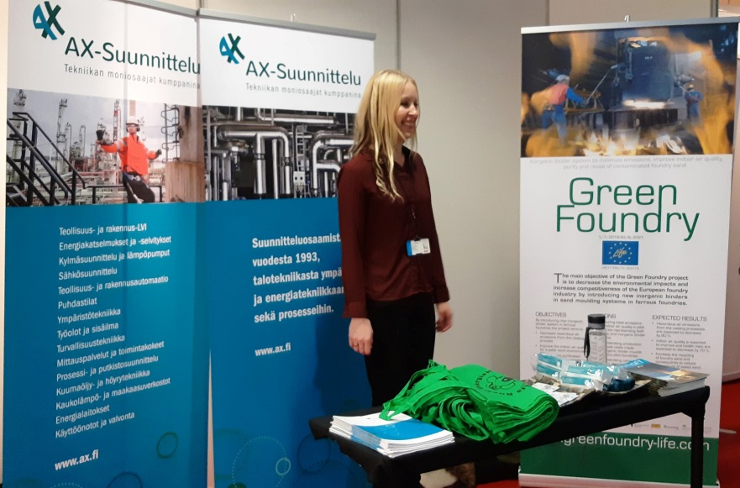

Ms Elina Ekeola-Özalp and Mr Seppo Heinänen participated this event.

1. Polish Foundrymen’s Day 2018 on 14.12.2018 in Krakow, Poland  
   <https://odo.foundry-conference.com/en/>.

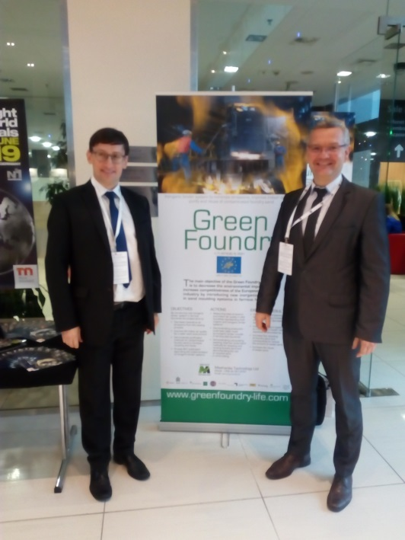

Prof. Rafal Danko at Polish Foundrymen´s Day 2018.